React crowdfunding website ‘Healium’ <https://keen-gecko-1cbdfe.netlify.app/>

Github repo: <https://github.com/what-the-hek/crowdfunding>

Apologies in advance for the intense colour, it was suppose to be a soft purple but my laptop screen betrayed me. I plan to fix this (and some other things) tomorrow.

Log in with ‘admin’ for username and password

Home page

Home page - projects

Support page (static)

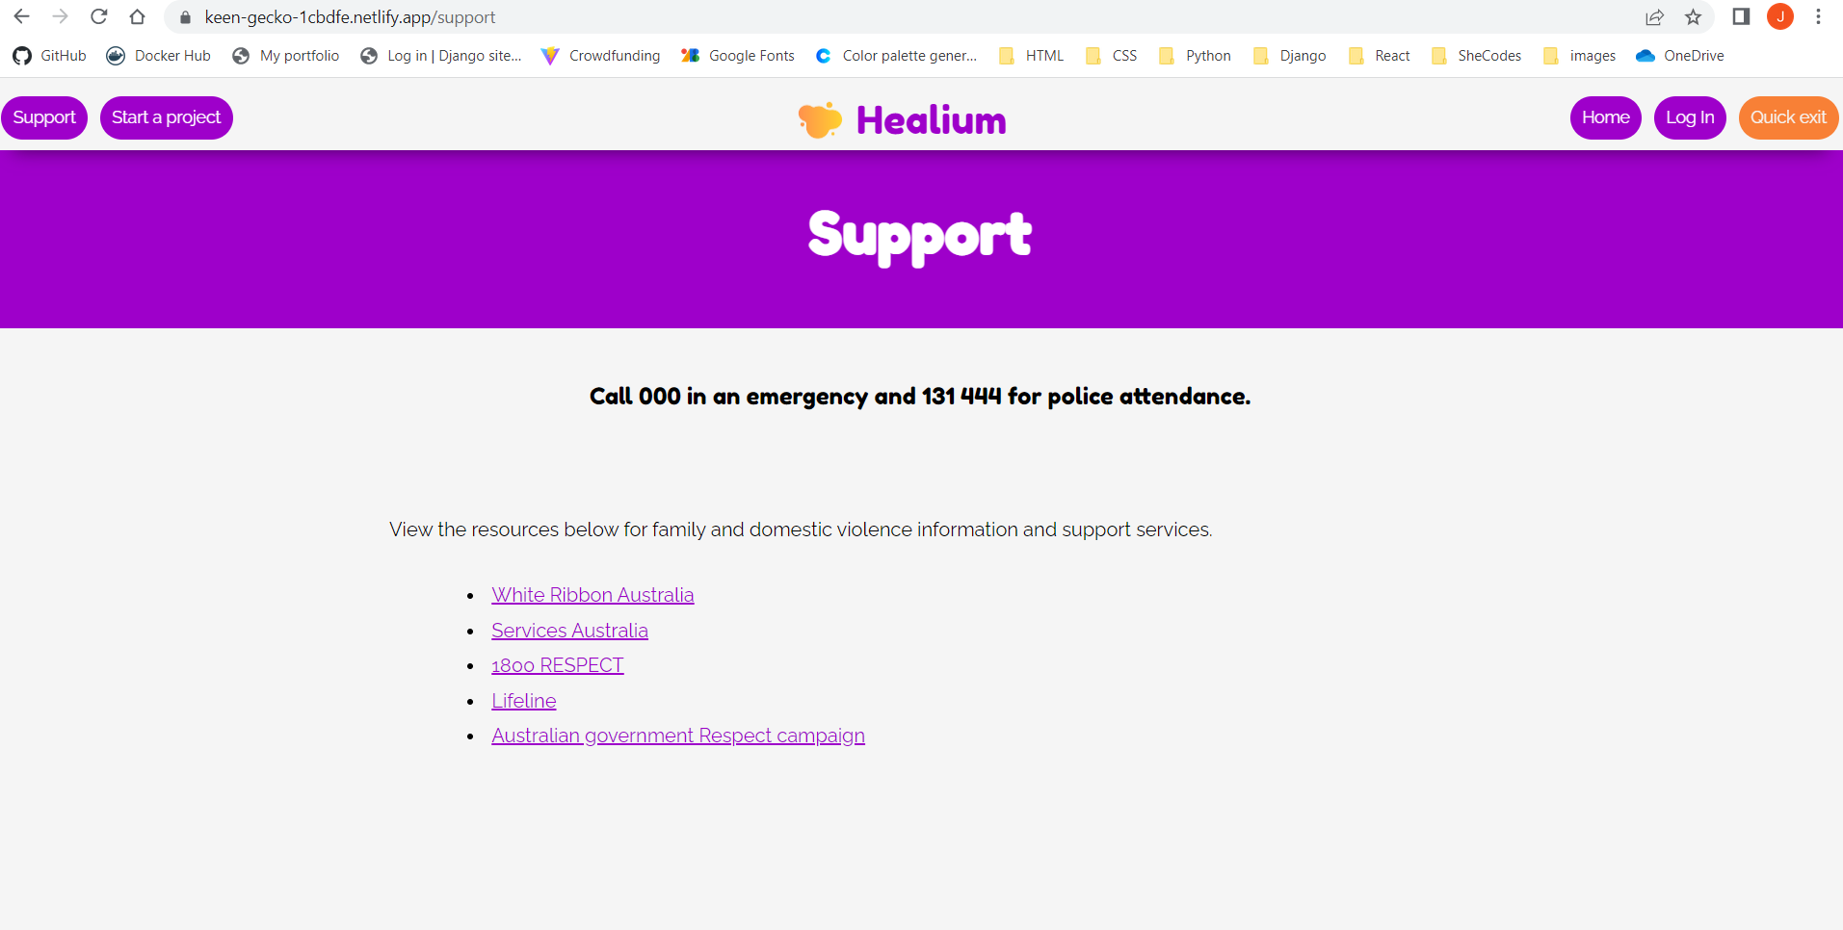

Log in page

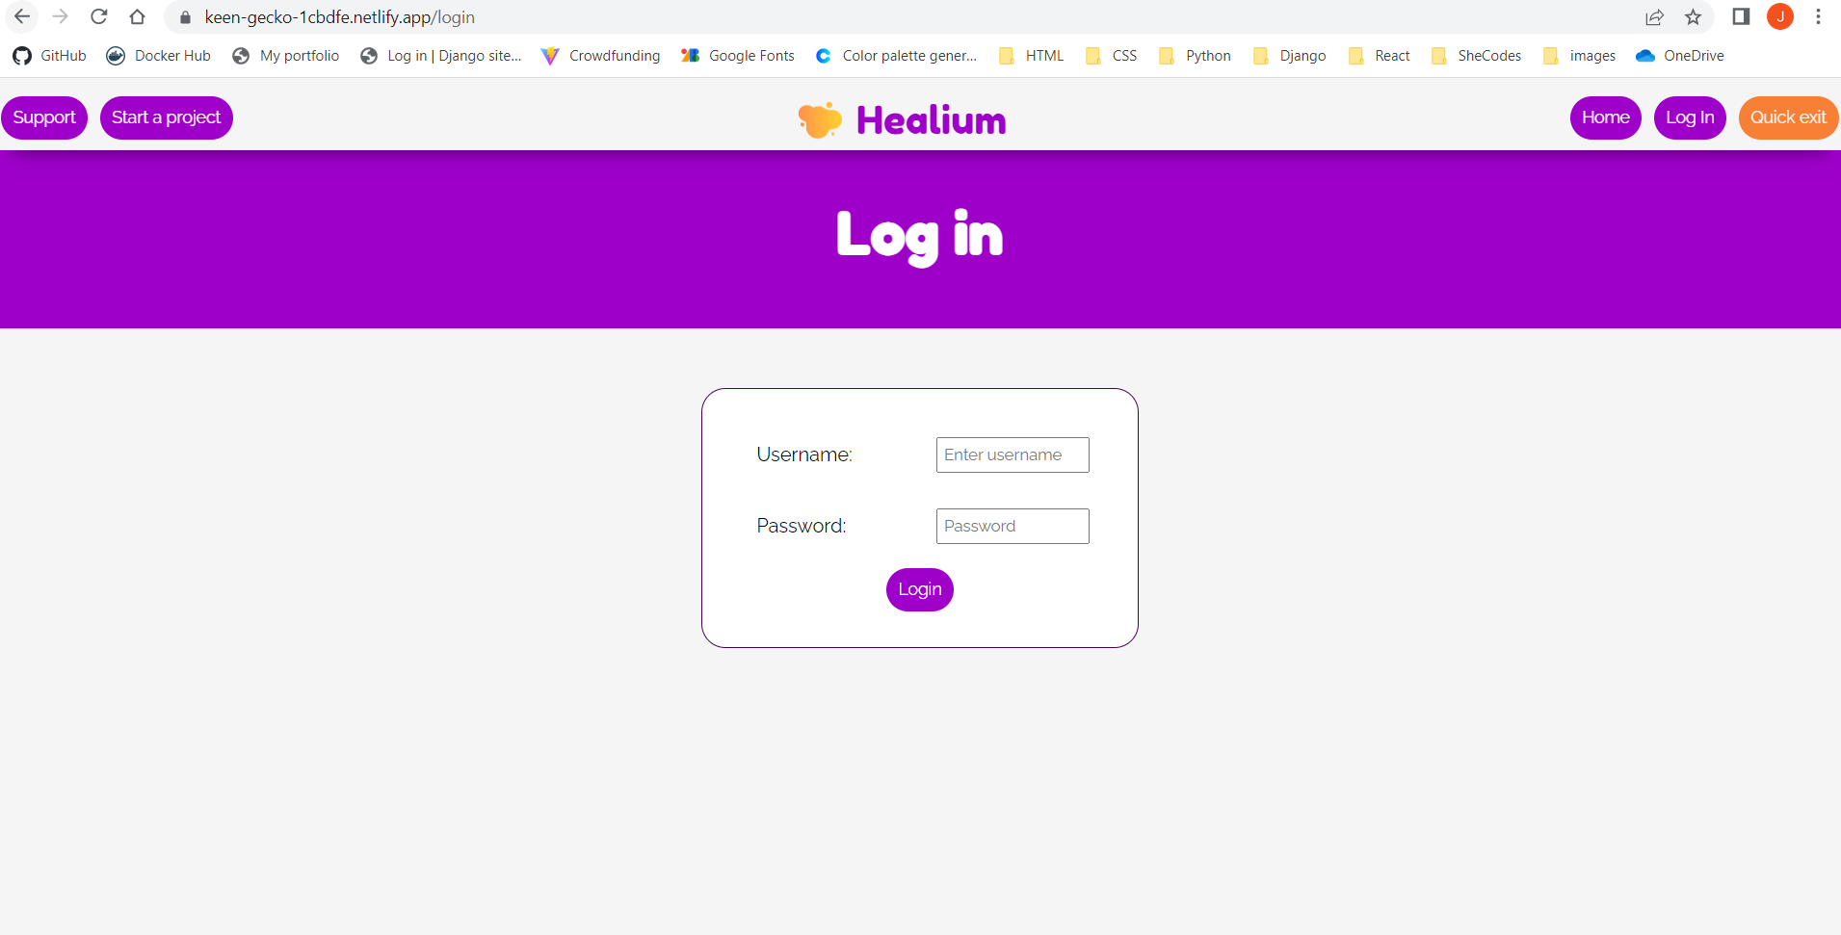

Start a project – logged out and in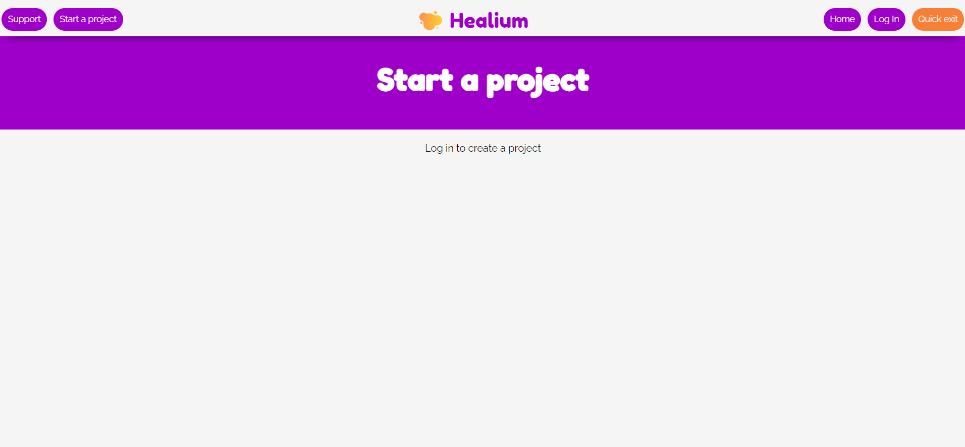

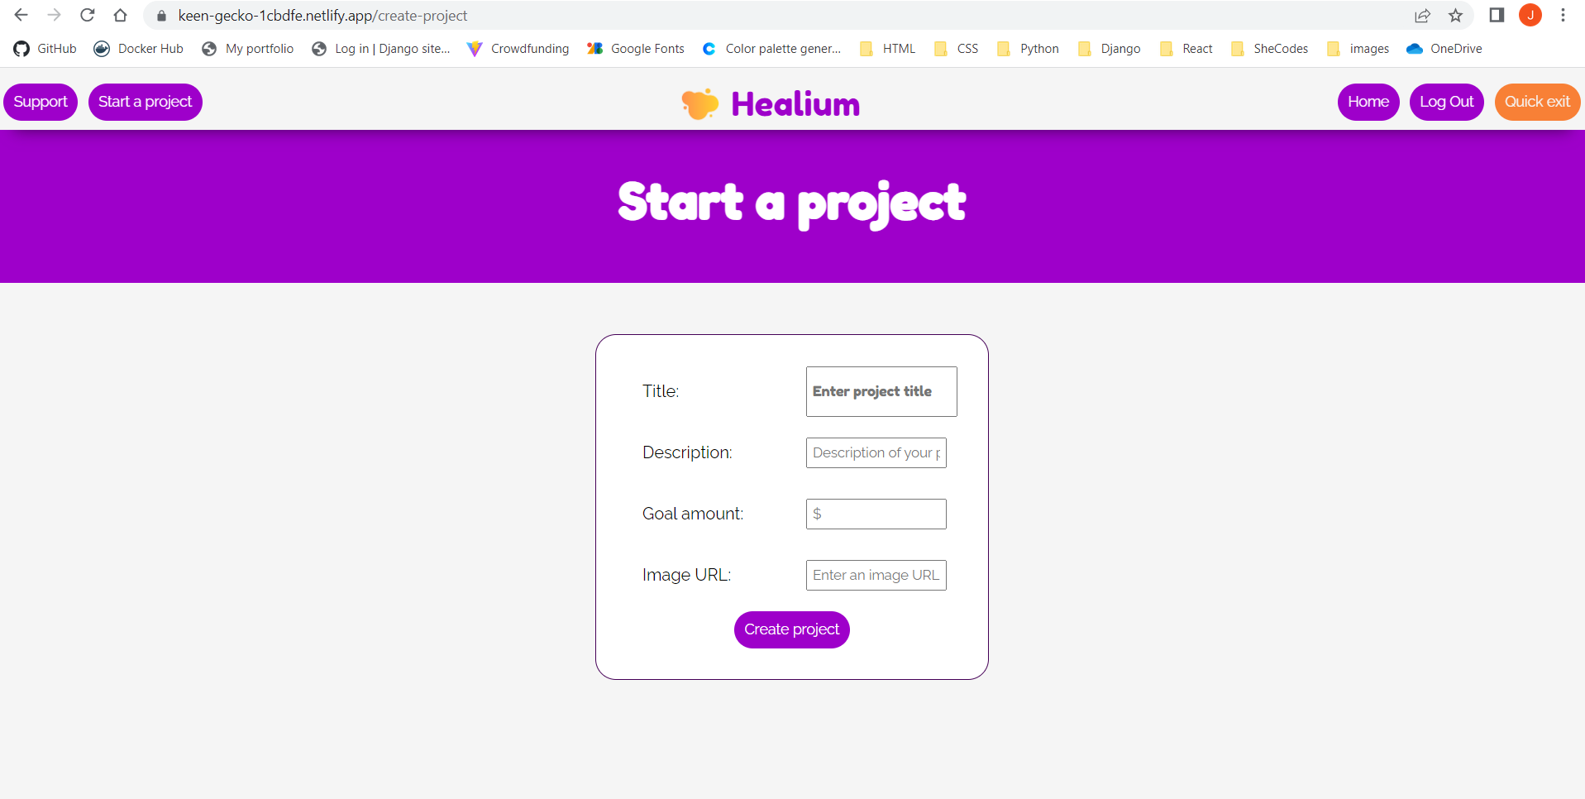

Project & pledge page – logged out

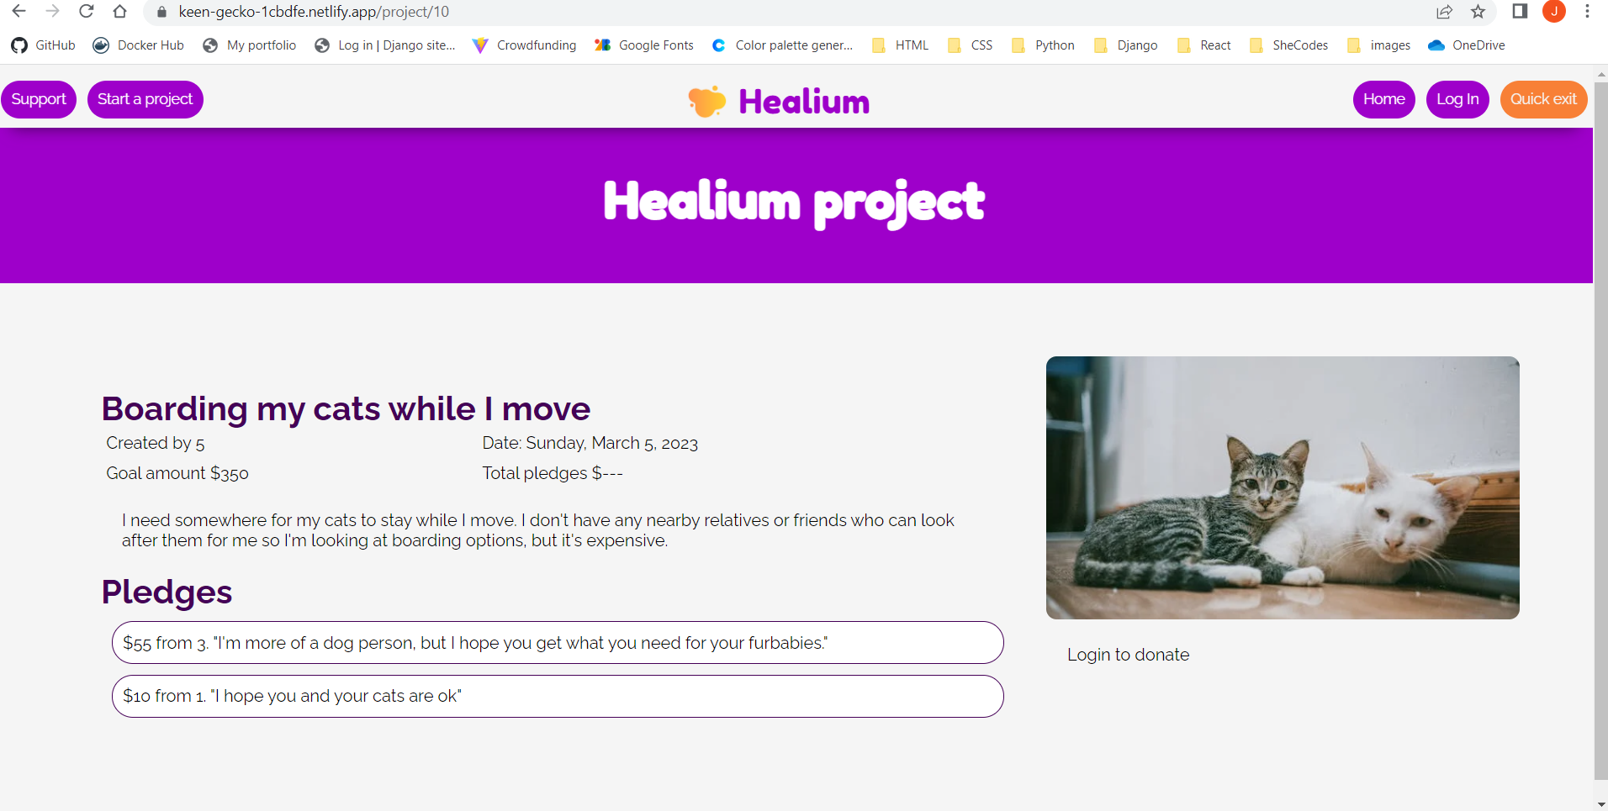

Project & pledge page – logged in

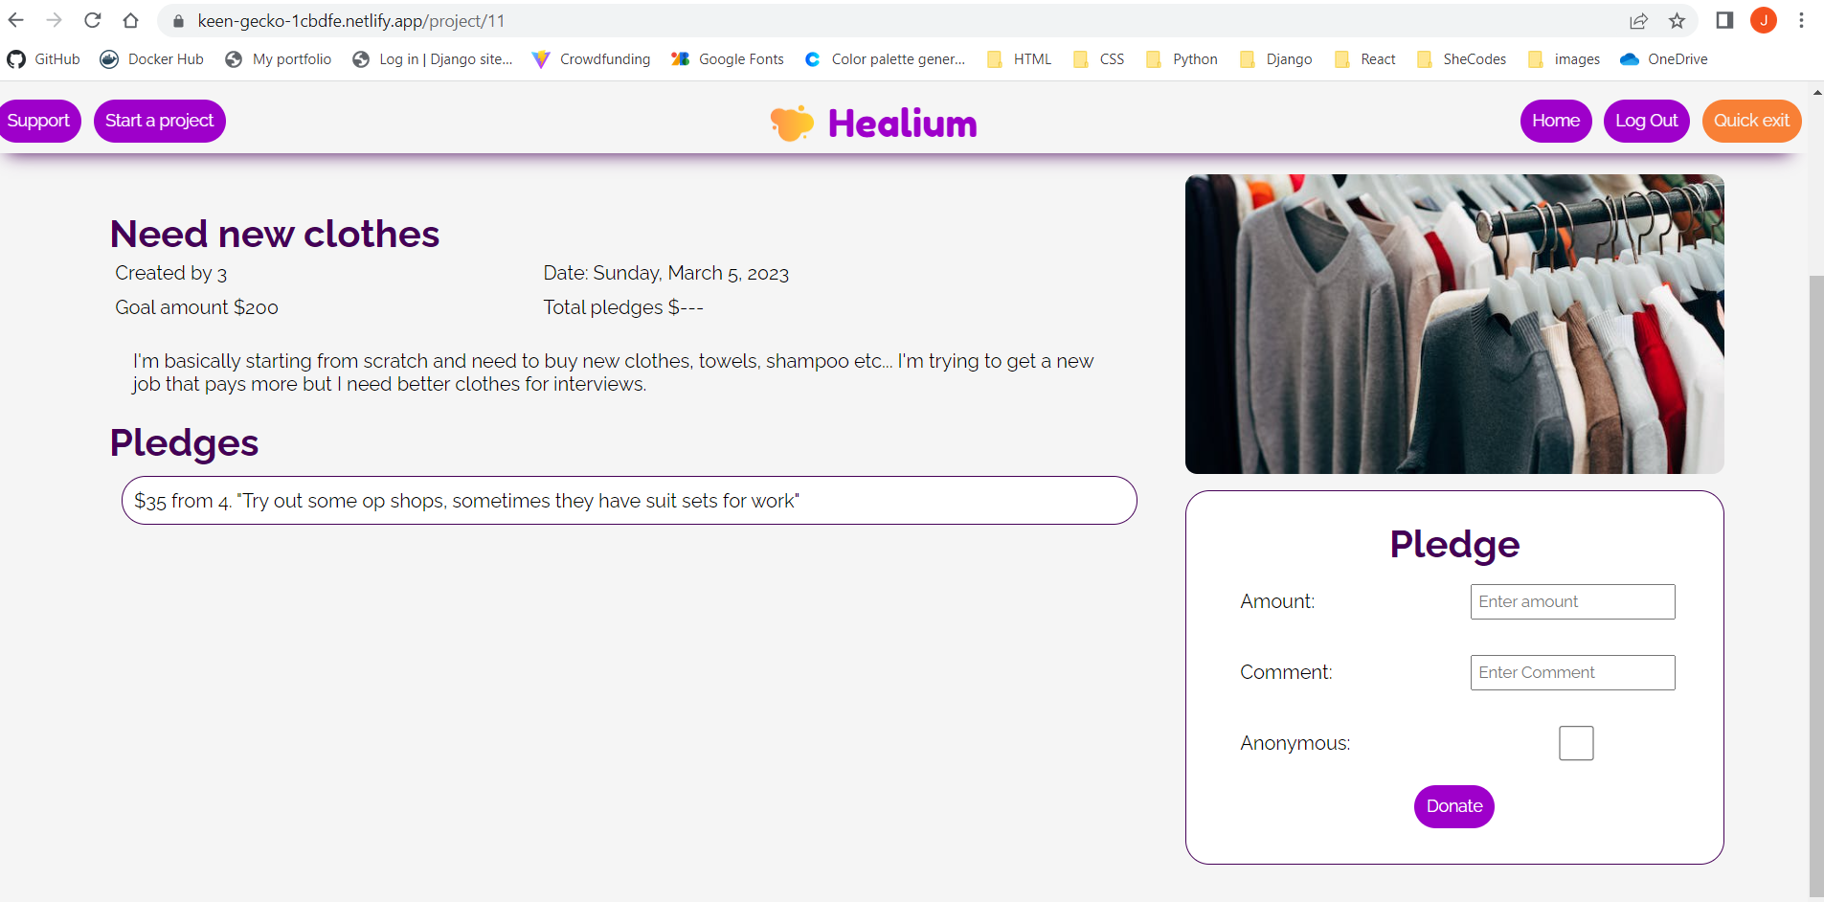

Quick exit button – logs out user, redirects existing tab to Google, opens new tab on BOM website

